How to Open your Lighthouse giving statement
- Go to www.lighthousealaska.org on your computer
- Click on the Giving tab

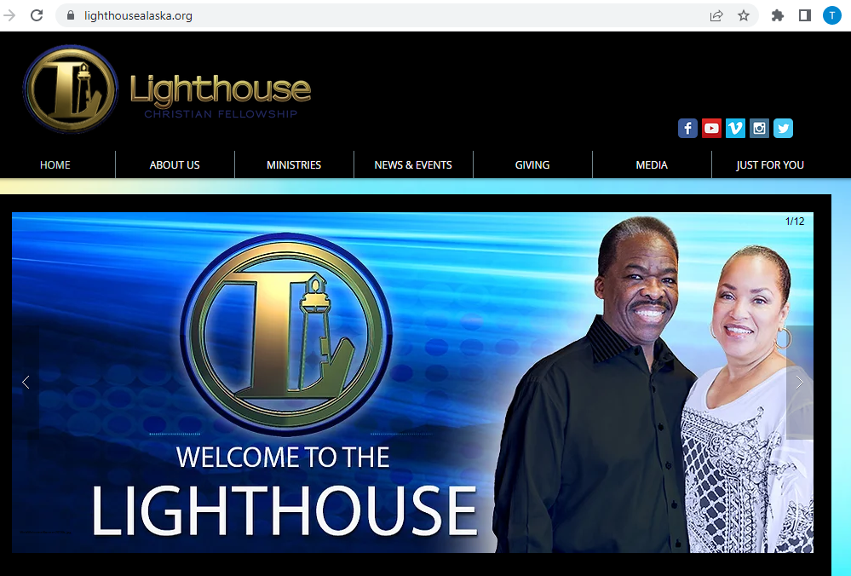

- In the Secure Giving Online information click on the Underlined option that says log in or create new member profile here.
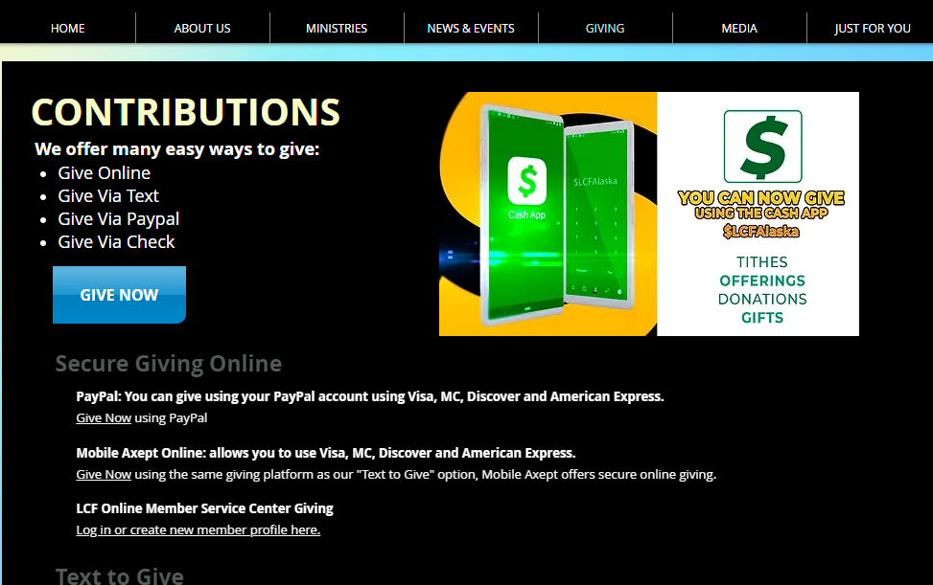

- Enter your email or mobile number and Password to retrieve your giving statement for 2022.
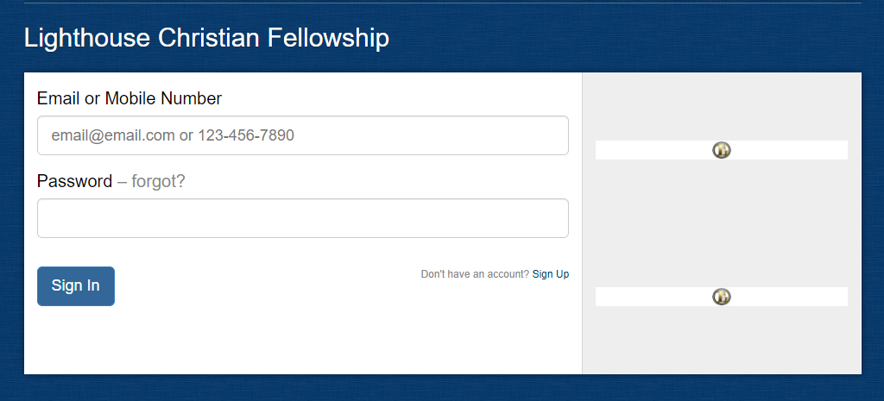
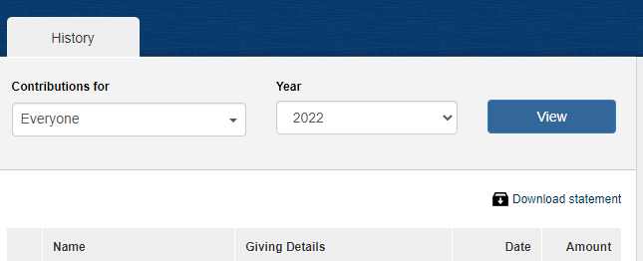

- If you have forgotten your password, click on the forgot link.

- Enter your email address and the Portal will email you your password.
- If you have any questions, please call 907-272-2252

